REVISION WORKSHEET
GRADE-VIII
PT-1
RATIONAL NUMBERS
I.ANSWER THE FOLLOWING.
1. Write the additive inverse of the following.
a) $\frac{-1}{2}$ b) $\frac{2}{5}$
2. Write multiplicative inverse of the following.
a) $\frac{-4}{6}$ b) 6$\frac{1}{8}$
3. Represent the following in number line.
a) $\frac{-5}{7}$ b) $\frac{4}{5}$
4. Find 5 rational numbers for the following.
a) $\frac{-1}{2} and\frac{1}{2}$ b) $\frac{-5}{6} and 6$ c) $\frac{3}{4} and \frac{7}{9}$ d) 6 and 7
e) -5 and -1
5. Simplify.
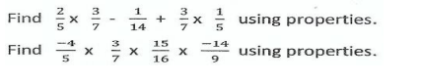
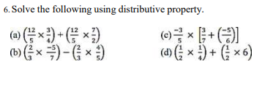

LINEAR EQUATION IN ONE VARIABLES
ANSWER THE FOLLOWING.
